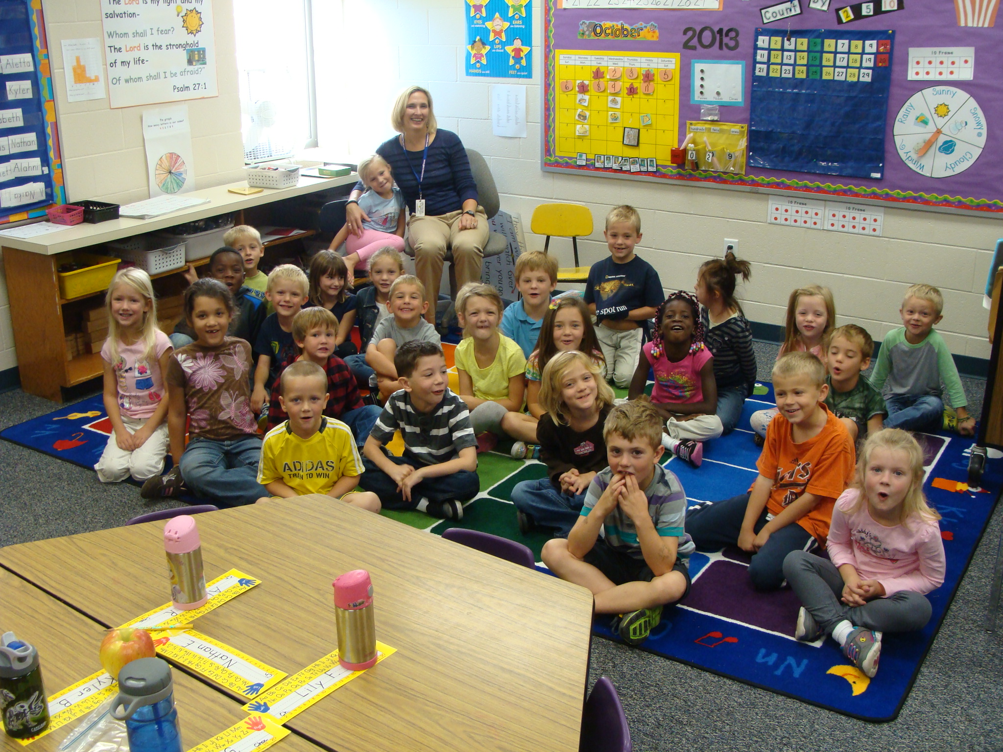

Kindergarten
News
Oct. 14-18

Dear Parents,

A very special “thank you” to Helena’s
family this week! Helena was our star student last week and her mom came to visit us and brought us our morning snack – popcorn! Thank you Becher family! When your child is star student you are welcome to visit our room, too.
On Tuesday, we will have our first out-door education class with Blandford Nature Center. Mrs. Janet Stall will be taking us into the nature preserve as “Fall Explorers!” Have your kids dress appropriately!
On Wednesday, you may have your child’s school picture retaken if you are unhappy with the ones that they brought home or it they were sick that day. If you already have a picture package at home and want retakes, you must return the old package and they will retake them. If their picture was not taken, and you want to order pictures, be sure to send their order form on Wednesday.
The rest of our week will look something like this;
BIBLE: We begin the story of Joseph. This is a long story and it will take us a few days to get through it. Our memory verse will be our school theme verse:
“The Lord is my light and my salvation. Whom shall I fear? The Lord is the stronghold of my life. Of whom shall I be afraid?” Psalm 27:1
READING: We have finished our letter name review and now begin with the letter sounds. We begin this week with the letters S and M. We use the “Letter People” puppets to introduce the sounds so you will hear about Mr. Mm and his Munchie Mouth and Ms. Ss and her Super Socks. Our popcorn word for the week will be: the.
MATH: We continue having fun with patterns!
SCIENCE: We have finished our unit on Plants and finish with our day in the nature center with Mrs. Staal. We will then begin a unit on keeping our bodies healthy.
Have a great week! In Christ, Judy

